QSFP+-40G-LR4
40Gb/s QSFP+ LR4 10KM Optical Module Transceiver
- Features
● Compliant with 40G Ethernet IEEE802.3ba and 40GBASE-LR4 Standard
● QSFP+ MSA compliant
● Compliant with QDR/DDR Infiniband data rates
● Up to 11.2Gb/s data rate per wavelength
● 4 CWDM lanes MUX/DEMUX design
● Up to 10km transmission on single mode fiber (SMF)
● Operating case temperature: 0 to 70 ℃
● Maximum power consumption 3.5W
● LC duplex connector
● RoHS compliant

- Applications
● 40GBASE-LR4 Ethernet Links
● Infiniband QDR and DDR interconnects
● Client-side 40G Telecom connections

- General Description
This product is a transceiver module designed for 2m-10km optical communication applications. The design is compliant to 40GBASE-LR4 of the IEEE P802.3ba standard. The module converts 4 inputs channels (ch) of 10Gb/s electrical data to 4 CWDM optical signals, and multiplexes them into a single channel for 40Gb/s optical transmission. Reversely, on the receiver side, the module optically de-multiplexes a 40Gb/s input into 4 CWDM channels signals, and converts them to 4 channel output electrical data.
The central wavelengths of the 4 CWDM channels are 1271, 1291, 1311 and 1331 nm as members of the CWDM wavelength grid defined in ITU-T G.694.2. It contains a duplex LC connector for the optical interface and a 148-pin connector for the electrical interface. To minimize the optical dispersion in the long-haul system, single-mode fiber (SMF) has to be applied in this module.
The product is designed with form factor, optical/electrical connection and digital diagnostic interface according to the QSFP+ Multi-Source Agreement (MSA). It has been designed to meet the harshest external operating conditions including temperature, humidity and EMI interference.

- Functional Description
This product converts the 4-channel 10Gb/s electrical input data into CWDM optical signals (light), by a driven 4-wavelength Distributed Feedback Laser (DFB) array. The light is combined by the MUX parts as a 40Gb/s data, propagating out of the transmitter module from the SMF. The receiver module accepts the 40Gb/s CWDM optical signals input, and de-multiplexes it into 4 individual 10Gb/s channels with different wavelength. Each wavelength light is collected by a discrete photo diode, and then outputted as electric data after amplified first by a TIA and a post amplifier. Figure 1 shows the functional block diagram of this product.
A single +3.3V power supply is required to power up this product. Both power supply pins VccTx and VccRx are internally connected and should be applied concurrently. As per MSA specifications the module offers 7 low speed hardware control pins (including the 2-wire serial interface): ModSelL, SCL, SDA, ResetL, LPMode, ModPrsL and IntL.
Module Select (ModSelL) is an input pin. When held low by the host, this product responds to 2-wire serial communication commands. The ModSelL allows the use of this product on a single 2-wire interface bus – individual ModSelL lines must be used.
Serial Clock (SCL) and Serial Data (SDA) are required for the 2-wire serial bus communication interface and enable the host to access the QSFP+ memory map.
The ResetL pin enables a complete reset, returning the settings to their default state, when a low level on the ResetL pin is held for longer than the minimum pulse length. During the execution of a reset the host shall disregard all status bits until it indicates a completion of the reset interrupt. The product indicates this by posting an IntL (Interrupt) signal with the Data_Not_Ready bit negated in the memory map. Note that on power up (including hot insertion) the module should post this completion of reset interrupt without requiring a reset.
Low Power Mode (LPMode) pin is used to set the maximum power consumption for the product in order to protect hosts that are not capable of cooling higher power modules, should such modules be accidentally inserted.
Module Present (ModPrsL) is a signal local to the host board which, in the absence of a product, is normally pulled up to the host Vcc. When the product is inserted into the connector, it completes the path to ground through a resistor on the host board and asserts the signal. ModPrsL then indicates its present by setting ModPrsL to a “Low” state.
Interrupt (IntL) is an output pin. “Low” indicates a possible operational fault or a status critical to the host system. The host identifies the source of the interrupt using the 2-wire serial interface. The IntL pin is an open collector output and must be pulled to the Host Vcc voltage on the Host board.

- Transceiver Block Diagram
Figure 1. Transceiver Block Diagram

- Pin Assignment and Description
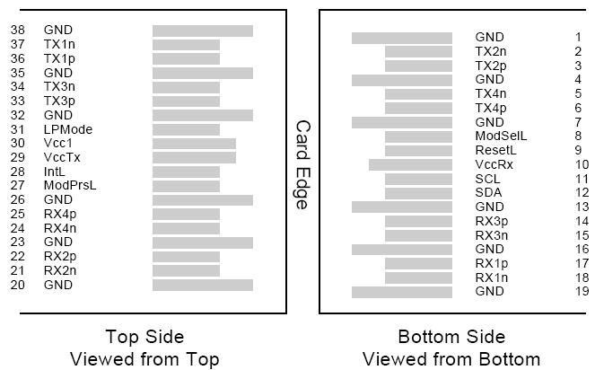
Figure 2. MSA compliant connector
- Pin Definition
PIN | Logic | Symbol | Name/Description | Notes
1 |  | GND | Ground | 1
2 | CML-I | Tx2n | Transmitter Inverted Data Input
3 | CML-I | Tx2p | Transmitter Non-Inverted Data output
4 |  | GND | Ground | 1
5 | CML-I | Tx4n | Transmitter Inverted Data Input
6 | CML-I | Tx4p | Transmitter Non-Inverted Data output
7 |  | GND | Ground | 1
8 | LVTLL-I | ModSelL | Module Select
9 | LVTLL-I | ResetL | Module Reset
10 |  | VccRx | +3.3V Power Supply Receiver | 2
11 | LVCMOS-I/O | SCL | 2-Wire Serial Interface Clock
12 | LVCMOS-I/O | SDA | 2-Wire Serial Interface Data
13 |  | GND | Ground
14 | CML-O | Rx3p | Receiver Non-Inverted Data Output
15 | CML-O | Rx3n | Receiver Inverted Data Output
16 |  | GND | Ground | 1
17 | CML-O | Rx1p | Receiver Non-Inverted Data Output
18 | CML-O | Rx1n | Receiver Inverted Data Output
19 |  | GND | Ground | 1
20 |  | GND | Ground | 1
21 | CML-O | Rx2n | Receiver Inverted Data Output
22 | CML-O | Rx2p | Receiver Non-Inverted Data Output
23 |  | GND | Ground | 1
24 | CML-O | Rx4n | Receiver Inverted Data Output | 1
25 | CML-O | Rx4p | Receiver Non-Inverted Data Output
26 |  | GND | Ground | 1
27 | LVTTL-O | ModPrsL | Module Present
28 | LVTTL-O | IntL | Interrupt
29 |  | VccTx | +3.3 V Power Supply transmitter | 2
30 |  | Vcc1 | +3.3 V Power Supply | 2
31 | LVTTL-I | LPMode | Low Power Mode
32 |  | GND | Ground | 1
33 | CML-I | Tx3p | Transmitter Non-Inverted Data Input
34 | CML-I | Tx3n | Transmitter Inverted Data Output
35 |  | GND | Ground | 1
36 | CML-I | Tx1p | Transmitter Non-Inverted Data Input
37 | CML-I | Tx1n | Transmitter Inverted Data Output
38 |  | GND | Ground | 1
Notes:

1.GND is the symbol for signal and supply (power) common for QSFP+ modules. All are common within the QSFP+ module and all module voltages are referenced to this potential unless otherwise noted. Connect these directly to the host board signal common ground plane.
2.VccRx, Vcc1 and VccTx are the receiving and transmission power suppliers and shall be applied concurrently. Recommended host board power supply filtering is shown in Figure 3 below. Vcc Rx, Vcc1 and Vcc Tx may be internally connected within the QSFP+ transceiver module in any combination. The connector pins are each rated for a maximum current of 500mA.
- Recommended Power Supply Filter
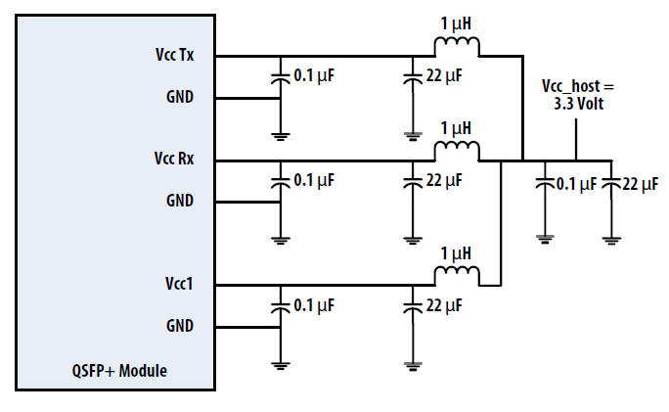
Figure 3. Recommended Power Supply Filter

- Absolute Maximum Ratings
It has to be noted that the operation in excess of any individual absolute maximum ratings might cause permanent damage to this module.

Parameter | Symbol | Min | Max | Units | Notes
Storage Temperature | TS | -40 | 85 | degC
Operating Case Temperature | TOP | 0 | 70 | degC
Power Supply Voltage | VCC | -0.5 | 3.6 | V
Relative Humidity (non-condensation) | RH | 0 | 85 | %
Damage Threshold, each Lane | THd | 3.3 |  | dBm

- Recommended Operating Conditions and Power Supply Requirements

Parameter | Symbol | Min | Typical | Max | Units
Operating Case Temperature | TOP | 0 |  | 70 | degC
Power Supply Voltage | VCC | 3.135 | 3.3 | 3.465 | V
Data Rate, each Lane |  |  | 10.3125 | 11.2 | Gb/s
Control Input Voltage High |  | 2 |  | Vcc | V
Control Input Voltage Low |  | 0 |  | 0.8 | V
Link Distance with G.652 | D | 0.002 |  | 10 | km

- Electrical Characteristics
The following electrical characteristics are defined over the Recommended Operating Environment unless otherwise specified.
Parameter | Symbol | Min | Typical | Max | Units | Notes
Power Consumption |  |  |  | 3.5 | W
Supply Current | Icc |  |  | 1.1 | A
Transceiver Power-on  Initialization Time |  |  |  | 2000 | ms | 1
Transmitter (each Lane)
Single-ended Input Voltage  Tolerance (Note 2) |  | -0.3 |  | 4.0 | V | Referred to  TP1 signal common
AC Common Mode Input  Voltage Tolerance |  | 15 |  |  | mV | RMS
Differential Input Voltage  Swing Threshold |  | 50 |  |  | mVpp | LOSA  Threshold
Differential Input Voltage  Swing | Vin,pp | 190 |  | 700 | mVpp
Differential Input  Impedance | Zin | 90 | 100 | 110 | Ohm
Differential Input Return Loss |  | See IEEE 802.3ba 86A.4.11 |  |  | dB | 10MHz-11.1GHz
J2 Jitter Tolerance | Jt2 | 0.17 |  |  | UI
J9 Jitter Tolerance | Jt9 | 0.29 |  |  | UI
Data Dependent Pulse Width Shrinkage (DDPWS ) Tolerance |  | 0.07 |  |  | UI
Eye Mask Coordinates  {X1, X2 Y1, Y2} |  | 0.11, 0.31  95, 350 |  |  | UI  mV | Hit Ratio =5x10-5
Receiver (each Lane)
Single-ended Output Voltage |  | -0.3 |  | 4.0 | V | Referred to signal common
AC Common Mode Output |  |  |  | 7.5 | mV | RMS
Voltage
Differential OutputVoltage  Swing | Vout,pp | 300 |  | 850 | mVpp
Differential Output Impedance | Zout | 90 | 100 | 110 | Ohm
Termination Mismatch at  1MHz |  |  |  | 5 | %
Differential Output Return Loss |  | See IEEE 802.3ba 86A.4.2.1 |  |  | dB | 10MHz-11.1GHz
Common Mode Output Return Loss |  | See IEEE 802.3ba 86A.4.2.2 |  |  | dB | 10MHz-11.1GHz
Output Transition Time |  | 28 |  |  | ps | 20% to 80%
J2 Jitter Output | Jo2 |  |  | 0.42 | UI
J9 Jitter Output | Jo9 |  |  | 0.65 | UI
Eye Mask Coordinates  {X1, X2 Y1, Y2} |  | 0.29, 0.5  150, 425 |  |  | UI  mV | Hit Ratio =5x10-5

Notes:
1. Power-on Initialization Time is the time from when the power supply voltages reach and remain above the minimum recommended operating supply voltages to the time when the module is fully functional.
2. The single ended input voltage tolerance is the allowable range of the instantaneous input signals.

- Optical Characteristics
Parameter | Symbol | Min | Typical |  | Max | Units | Notes
Wavelength Assignment | L0 | 1264.5 | 1271 |  | 1277.5 | nm
 | L1 | 1284.5 | 1291 |  | 1297.5 | nm
 | L2 | 1304.5 | 1311 |  | 1317.5 | nm
 | L3 | 1324.5 | 1331 |  | 1337.5 | nm
Transmitter
Side Mode Suppression Ratio | SMSR | 30 |  |  |  | dB
Total Average Launch Power | PT |  |  |  | 8.3 | dBm
Average Launch Power, each Lane | PAVG | -7 |  |  | 2.3 | dBm
Optical Modulation Amplitude  (OMA), each Lane | POMA | -4 |  |  | 3.5 | dBm | 1
Difference in Launch Power between any Two Lanes (OMA) | Ptx,diff |  |  |  | 6.5 | dB
Launch Power in OMA minus  Transmitter and Dispersion  Penalty (TDP), each Lane |  | -4.8 |  |  |  | dBm
TDP, each Lane | TDP |  |  |  | 2.6 | dB
Extinction Ratio | ER | 3.5 |  |  |  | dB
Relative Intensity Noise | RIN |  |  |  | -128 | dB/Hz | 12dB  reflection
Optical Return Loss Tolerance | TOL |  |  |  | 20 | dB
Transmitter Reflectance | RT |  |  |  | -12 | dB
Transmitter Eye Mask Definition  {X1, X2, X3, Y1, Y2, Y3} |  | {0.25,0.4,0.45,0.25,0.28,0.4}
Average Launch Power OFF  Transmitter, each Lane | Poff |  |  |  | -30 | dBm
Receiver
Damage Threshold, each Lane | THd | 3.3 |  |  |  | dBm | 2
Total Average Receive Power |  |  |  |  | 8.3 | dBm
Average Receive Power, each Lane |  | -13.7 |  |  | 2.3 | dBm
Receiver Reflectance | RR |  |  |  | -26 | dB
Receive Power (OMA), each Lane |  |  |  |  | 3.5 | dBm
Receiver Sensitivity (OMA), eachLane | SEN |  |  |  | -11.5 | dBm
Stressed Receiver Sensitivity  (OMA), each Lane |  |  |  |  | -9.6 | dBm | 3
Difference in Receive Power  between any Two Lanes (OMA) | Prx,diff |  |  |  | 7.5 | dB
LOS Assert | LOSA | -28 |  |  |  | dBm
LOS Deassert | LOSD |  |  |  | -15 | dBm
LOS Hysteresis | LOSH | 0.5 |  |  |  | dB
Receiver Electrical 3 dB upper  Cutoff Frequency, each Lane | Fc |  |  |  | 12.3 | GHz
Conditions of Stress Receiver Sensitivity Test (Note 4)
Vertical Eye Closure Penalty, each Lane |  |  | 1.9 |  |  | dB
Stressed Eye J2 Jitter, each Lane |  |  | 0.3 |  |  | UI
Stressed Eye J9 Jitter, each Lane |  |  | 0.47 |  |  | UI

Notes:

1.Even if the TDP < 0.8 dB, the OMA min must exceed the minimum value specified here.
2.The receiver shall be able to tolerate, without damage, continuous exposure to a modulated optical input signal having this power level on one lane. The receiver does not have to operate correctly at this input power.
3.Measured with conformance test signal at receiver input for BER = 1x10-12.
4.Vertical eye closure penalty and stressed eye jitter are test conditions for measuring stressed receiver sensitivity. They are not characteristics of the receiver.

- Digital Diagnostic Functions

The following digital diagnostic characteristics are defined over the normal operating conditions unless otherwise specified.

Parameter | Symbol | Min | Max | Units | Notes
Temperature monitor absolute error | DMI_Temp | -3 | +3 | degC | Over operating temperature range
Supply voltage monitor absolute error | DMI _VCC | -0.1 | 0.1 | V | Over full operating range
Channel RX power monitor absolute error | DMI_RX_Ch | -2 | 2 | B | 1
Channel Bias current  monitor | DMI_Ibias_Ch | -10% | 10% | mA
Channel TX power monitor  absolute error | DMI_TX_Ch | -2 | 2 | dB | 1

Notes:
1 . D ue to m e a s u r e m e n t a c c u ra c y o f d iff e r e n t s in g le m o d e fib e r s , th e r e c o u ld b e a n a d d itio n a l + / - 1 d B fl u c tu a tio n , o r a + / - 3 d B to ta l a c c u r a c y .
- Mechanical Dimensions
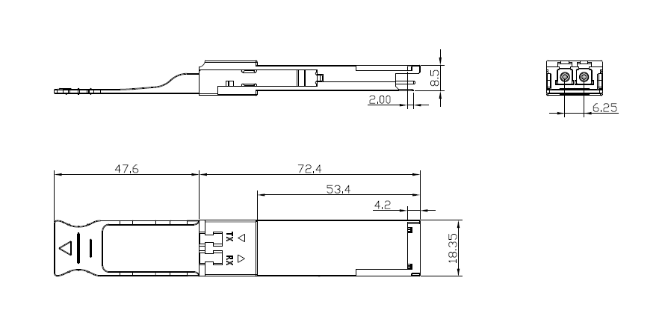
Figu re 4. Mec han ical Outline
- ESD
This transceiver is specified as ESD threshold 1kV for SFI pins and 2kV for all other electrical input pins, tested per MIL-STD-883, Method 3015.4 /JESD22-A114-A (HBM). However, normal ESD precautions are still required during the handling of this module. This transceiver is shipped in ESD protective packaging. It should be removed from the packaging and handled only in an ESD protected environment.
- Laser Safety
This is a Class 1 Laser Product according to IEC 60825-1:2007. This product complies with 21 CFR 1040.10 and 1040.11 except for deviations pursuant to Laser Notice No. 50, dated (June 24, 2007).

